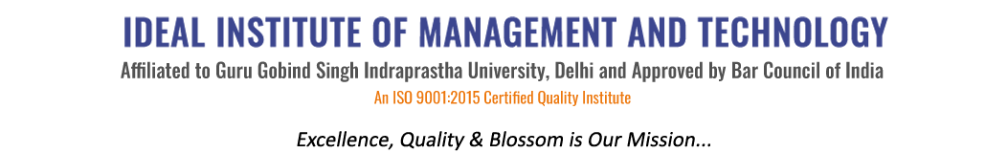
16 X, Karkardooma Institutional Area, (Near Telephone Exchange)
Delhi-110092
+91 (11) 22372639, 22375961,
http://idealinstitute.edu.in
INDUSTRIAL VISIT: IMPERIAL MALT- 19TH AUGUST 2017
BBA 2ND SHIFT
SNO. | NAME
 | BBA GEN 3
1 | Aman
2 | Pranjal
3 | Sukhleen
4 | Akshay
5 | Amber
6 | Naman
7 | Yash
8 | Megha
9 | Bhawna
10 | Rahul
11 | Piyush Chawla
12 | Ankit
13 | Mahak
14 | Ayushi
15 | Kiran
16 | Gagan
17 | Shivam Nagpal
18 | Nejal
 | BBA GEN 5
19 | Jigyasu
20 | Lakshay
21 | Rahul
 | BBA CAM 5
22 | Lakshay
 | BBA GEN 1
23 | Sakshi Jain
24 | Sakshi Joshi
25 | Tanya
26 | Somya
27 | Ayushi
28 | Rishabh
29 | Srijan
30 | Varun
31 | Apoorv
32 | Vaibhav
33 | Arpit
34 | Mudit
35 | Gaurav
36 | Garima
37 | Chesta
38 | Archit
39 | Ishita
40 | Saksham Gulati

